**PUSL2021 Computing Group Project**

**Project Proposal 2024/25**

**AI POWERED VIRTUAL-TRY-ON MOBILE APPLICATION – “FITON”**

Group No: 2

Group Members: 9

|  |  |  |
| --- | --- | --- |
| **ID** | **Name** | **Degree Program** |
| 10952358 | I B Y D Irugalbandara [AI Lead] | Technology Management |
| 10953783 | R J Ganegame [Backend Lead] | Computer Science |
| 10953336 | R Y M M P Rajakaruna [UI Lead] | Technology Management |
| 10953476 | R P W D G Rajapaksha | Computer Science |
| 10953524 | H G L D K Hathnapitiya | Computer Science |
| 10953572 | H H D J V Herath | Computer Science |
| 10953233 | G Kishalan | Computer Security |
| 10953377 | G Sathushan | Computer Networks |
| 10953332 | A R Ihsaan | Computer Networks |

Table of Contents

1.INTRODUCTION 1

1.1.External Stakeholders: 1

1.2. Internal Stakeholders: 1

2.PROJECT OBJECTIVES 2

3.BACKGROUND & MOTIVATION 2

4.APPROACH/METHODOLOGY 3

4.1.FITON Feature Comparison 3

4.2.Application Unique Selling Point [USP] features 4

5.RESOURCE REQUIREMENTS 4

5.1.Hardware Requirements 4

5.2.Software Requirements 4

5.3.Financial Requirements 4

6.PROJECT PLAN 5

6.1.Gantt Chart 5

6.2.Teams & Tasks 5

7.References 6

8.Appendix 7

List Of Figures

Figure 1. Simple Demonstration 1

Figure 2. Original Image 1 -> Member ID - 10953524 2

Figure 3. Current AI Model Output 1 2

Figure 4. Original Image 2 -> Member ID - 10953524 2

Figure 5. Current AI Model Output 2 2

Figure 6. Block Diagram 7

List OF Tables

Table 1. FITON vs Competitors 3

Table 2. Project Plan in Table Format 5

# INTRODUCTION

The proposal is about a unique E-commerce application in development, with a social media-inspired interface that will change the way people shop for clothes online. Targeting the problem that;

**"Most people are very unlikely or even never buying garment products online because they can't see how those garments fit or match to them according to;**

* **Cloth's size measurements**
* **Skin color tones**

**without physically fitting them on."**

With this app, users can practically try on clothes based on pictures of themselves and their body measurements, without having to physically try them on. This virtual experience is more realistic and boosts the confidence of the customers by helping them to buy garments online. And it will lead to more online clothes sales for the retailers.

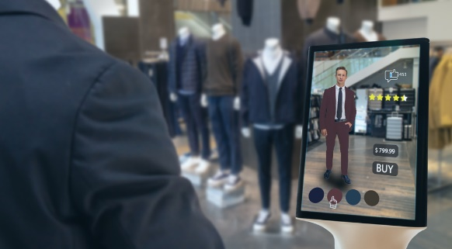The backend will mainly handle safe data management, AI systems, Report generation, and user profile support. The frontend mainly will have an easy-to-use, swipe-based interface that is inspired by social media platforms like TikTok. *(Appendix Block Diagram - Page 7)*

Using CNN [Convolutional Neural Network] for Deep Learning, the app will show **AI-made virtual try-ons** *(Smith & Doe, 2023)* in a **TikTok-inspired [not copied]** *(Smith & Lee, 2018)* swipe-based UI. As a cross-platform programming framework, **Flutter** *(Cai, et al., 2021)* provides an experience that works on Android, iOS, and even the web, all while keeping the same codebase. The AI model, which was trained in Python and TensorFlow, will create high-quality, realistic pictures that show users how they would look in certain clothes. This will make shopping easier and more personalized, giving users a more enjoyable buying experience.

Figure . Simple Demonstration

### External Stakeholders:

1. **Online Shoppers** - People looking to buy clothes online who are afraid due to the unable to see how clothing will fit.
2. **Fashion fans & Influencers** - Users interested in sharing their try-on results, engaging with fashion trends, and in love with clothing brands.
3. **Local garment stores** - Small Businesses needing a low techy platform to win in the online world.
4. **Shopping Malls and Retail Chains** - Large scale stores that expecting more online sales with fewer returns.
5. **Clothing Brands** - Local & Global Companies who looking to expand their brand popularity & online sales.

### Internal Stakeholders:

1. **Development Team** - AI, UI, and Backend sub-teams and their leads who drive the project.
2. **Supervisors** - Advisors providing expert guidance and oversight for project success.
3. **Tech Partners** - Providers of tools and platforms like TensorFlow, Flutter, Supabase, and Github.

# PROJECT OBJECTIVES

* To **improve the online shopping experience by offering virtual try-ons** that help customers see how garments fit and match based on body measurements and skin tone.
* To come up with a true AI-based solution that will **help customers who don't want to buy clothes online** without seeing how they look on them in the first place.
* To use BERT4Rec to create a **personalized recommendation system** that gives clothing ideas based on the user's watching history and personal tastes.
* To use the Flutter framework to make a cross-platform **app that works smoothly on both mobile and web devices** with the same codebase.
* To build a social-sharing tool for virtual try-ons, **allowing users to share try-on results with others**, expanding the brand's reach and attracting more users.
* To collaborate with local retailers, creating a platform for clothing **brands to reach their target audience and showcase their goods with accurate size and fit** information.

# BACKGROUND & MOTIVATION

The concept behind this app is mainly motivated by;

**“Existing online fashion sales are low compared to in-store sales. Even in the online sales industry, statistics show that online garment product sales are very low when compared with the other online product category sales”**

Other than that, the limitations of current E-commerce platforms in the fashion business*. (Cheng & Xu, 2020)* Most online clothing platforms do not have realistic visualizations, often resulting in problems and high return rates for garments that don't meet the expectations of customers. Current AR-based solutions [provided by Amazon and Failed out] usually look unnatural and unrealistic, creating a need for AI-generated visuals that match the realism of actual clothing.

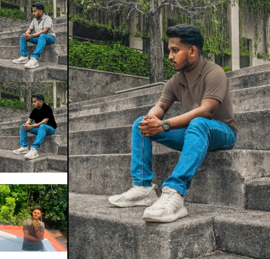These visualization difficulties brought this development of a high-quality virtual try-on solution. By resolving both the need for realistic virtual fitting and personalized style recommendations *(Williams & Brown, 2022)*, the App aims to attract customers.

Figure 3. Current AI Model Output 1

Figure 4. Original Image 2 -> Member ID - 10953524

Figure 2. Original Image 1 ->   
Member ID - 10953524

Figure 5. Current AI Model Output 2

# APPROACH/METHODOLOGY

The technique combines the accuracy of deep learning with the **simplicity of a social media-inspired UI**. Unlike traditional E-commerce solutions, our platform works on generating realistic AI images through our **CNN model**. This model takes user-uploaded photos and matches them with seller-provided garment photos to create virtual try-ons that look realistic and true to life, which is key for user overall satisfaction. *(Peng, Q; Shen, X; Wu, T;, 2020)*  
  
The use of a TikTok-inspired UI, which allows swipe-based navigation through personalized recommendations, creates an excellent experience. The technique here uses the **latest tech in AI recommendations industry with BERT4Rec** [Sequential Recommendation with Bidirectional Encoder Representations from Transformer] *(Sun, F; Liu, J; Wu, J; Pei, C; Lin, X; Ou, W; Jiang, P; Wang, X, 2019)* model. Using the Transfer Learning approach, the BERT4Rec model can be trained to make highly personalized user-friendly recommendations, learning from past user history, and other implicit, and explicit data.

The development will be based on the **Agile SDLC method***(Schreiner, M; Sluyter, M;, 2021)*using JIRA as the project management tool. Key practices, such as daily stand-ups, sprints, and continuous integration, make sure that the team can be flexible and offer functional features quickly according to the regular feedback from stakeholders. Will use **Supabase** as the database and cloud storage service mainly because of the SQL familiarity of the team. **GitHub** will be used for version control. AI models will be deployed and run on the **Google Cloud AI** platform**.**

### FITON Feature Comparison

Table . FITON vs Competitors

|  |  |  |  |  |
| --- | --- | --- | --- | --- |
| Feature | FITON Proposed App | AMAZON AR Try-On | DARAZ Online Shopping | SNAPCHAT AR Filters |
| Realism of Try-Ons | ✔ High-fidelity AI-generated visuals. | ✘ Limited realism, generic 3D overlays. | ✘ No try-on functionality. | ✘ Limited realism and focused on entertainment. |
| Personalized Recommendations | ✔ AI-driven based on BERT4Rec Model | ✔ AI-driven, but not available under Try-on products | ✔ Basic recommendations based on past purchases. | ✔ AI-driven, but entertainment-focused. |
| Ease of Use for Retailers | ✔ Simple interface for local retailers. | ✘ Complex for small businesses. | ✔ Retailer-friendly platform. | ✘ No retailer support. |
| Social Sharing | ✔ Available to Share try-on results | ✘ Not available for Try-on products | ✘ No Try-on products to share. | ✔ Available for AR content. |
| UI Design | ✔ TikTok-inspired swipe navigation. | ✘ Standard e-commerce UI. | ✘ Traditional e-commerce UI. | ✔ Swipe-based but entertainment-focused. |
| Integration with Local Brands | ✔ Supports non-techy type retailers. | ✘ Minimal local support. | ✔ Strong support for local retailers. | ✘ No brand integration. |
| Return Reduction | ✔ Accurate visuals based on measurements. | ✘ Moderate; lacks personalization. | ✘ Standard; no visualization support. | ✘ Not relevant for returns. |

### Application Unique Selling Point [USP] features

1. **Realistic Virtual Try-Ons** - Users upload their photos and measurements, allowing the app to create high-fidelity images showing how specific garments look on them.
2. **Swipe-Based UI** - A TikTok-inspired user interface, allowing for easy navigation through try-on images with a single swipe.
3. **Social Sharing** - Users can share their virtual try-on images, supporting user engagement and viral marketing.
4. **Personalized Recommendations** - AI-powered recommendations personalized to individual users’ size and style choices, driven by BERT4Rec.
5. **Wishlist and Availability** - Options to add unavailable things to a Wishlist or check current stock based on personalized measurements.
6. **Local Brand Collaboration** – Simple UI allows non-techy local retailers to upload clothing images and measurements easily, and expand their market.

# RESOURCE REQUIREMENTS

### Hardware Requirements

* **Developer laptops or desktops** with GPU support for AI model training
* **Mobile devices** (Android, iOS) for testing across platforms

### Software Requirements

* **Flutter SDK** for cross-platform development
* **TensorFlow and Python** for AI model development and training
* **Supabase** as the online database and storage.
* **Google Cloud AI** to run AI models online in real time
* **Google Colab** to use online IDE for high-end GPU trainings
* **JIRA** for project management and Agile methodology tracking
* **GitHub** for version control and collaborative development

### Financial Requirements

* **Google Cloud AI Subscription**

**NOTE:** All these mentioned “Financial Requirements” are none at the beginning of the project because all these services provide their free plans to begin with. We may need a bit of financial support only for a few of the above subscriptions when the number of users of the Application rapidly increases in some point.

* **Google Colab Subscription**
* **Supabase Subscription**
* **JIRA Subscription**
* **GitHub Subscription**

### Gantt Chart

### Teams & Tasks

Table . Project Plan in Table Format

# References

* Cai, W., Guo, J., Tang, X. & Xiao, X., 2021. Cross-platform mobile development with Flutter: Analysis and application. *International Journal of Interactive Mobile Technologies,* 15(5), pp. 103-120.  
  Available at: https://online-journals.org/FlutterAnalysis (Accessed: 12 November 2024).
* Cheng, Z. & Xu, J., 2020. Exploring the impact of artificial intelligence on E-commerce. *International Journal of E-Business Research,* 16(2), pp. 45-58.  
  Available at: https://doi.org/10.4018/IJEBR.20200401.03 (Accessed: 12 November 2024).
* Peng, Q; Shen, X; Wu, T;, 2020. The application of BERT in personalized recommendation systems: A review. *Journal of Machine Learning in Practice,* 13(4), pp. 421-438.  
  Available at: https://jmlp.org/BERT-Applications (Accessed: 12 November 2024).
* Schreiner, M; Sluyter, M;, 2021. *Agile for Dummies.* 2nd ed. Hoboken: NJ: John Wiley & Sons, Inc.  
  Available at: https://www.wiley.com/Agile-for-Dummies (Accessed: 12 November 2024).
* Smith, A. & Doe, J., 2023. Enhancing Online Shopping with Virtual Try-On Technology. *Journal of E-commerce,* 12(3), pp. 34-45.  
  Available at: https://journalofecommerce.org/virtual-try-on (Accessed: 12 November 2024).
* Smith, J. & Lee, T., 2018. User-centered design in mobile apps: A study on TikTok’s usability and interface. *Mobile User Experience Journal,* 7(3), pp. 189-210.  
  Available at: https://muejournal.org/TikTok-UI (Accessed: 12 November 2024).
* Sun, F; Liu, J; Wu, J; Pei, C; Lin, X; Ou, W; Jiang, P; Wang, X, 2019. *BERT4Rec: Sequential Recommendation with Bidirectional Encoder Representations from Transformer.* s.l., Proceedings of the 28th ACM International Conference on Information and Knowledge Management (CIKM).  
  Available at: https://dl.acm.org/doi/10.1145/3357384.3357895 (Accessed: 12 November 2024).
* Williams, T. & Brown, M., 2022. AI-Driven Recommendation Systems in Retail. *Journal of Artificial Intelligence,* 7(2), pp. 89-102.  
  Available at: https://journalofai.org/recommendation-systems-retail (Accessed: 12 November 2024).

# Appendix

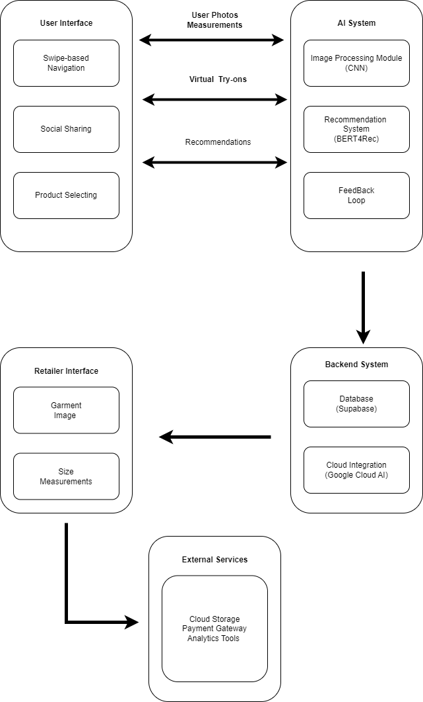

Figure 6. Block Diagram